Now that you have gotten used to Java’s Swing library to build GUIs, you will rewrite your Battleship project using a graphical user interface. You are free to use your code from your last project, the code we developed in class and/or my solution. You may not use any GUI code that is not your own. Furthermore, you must use NetBeans and create a project called NetBeansGUI, but you are free to manually write your code or use its GUI builder; just be aware of the pros and cons of each approach.

Part 1 – Creating the Interface

When the program begins, it must load the following screen:
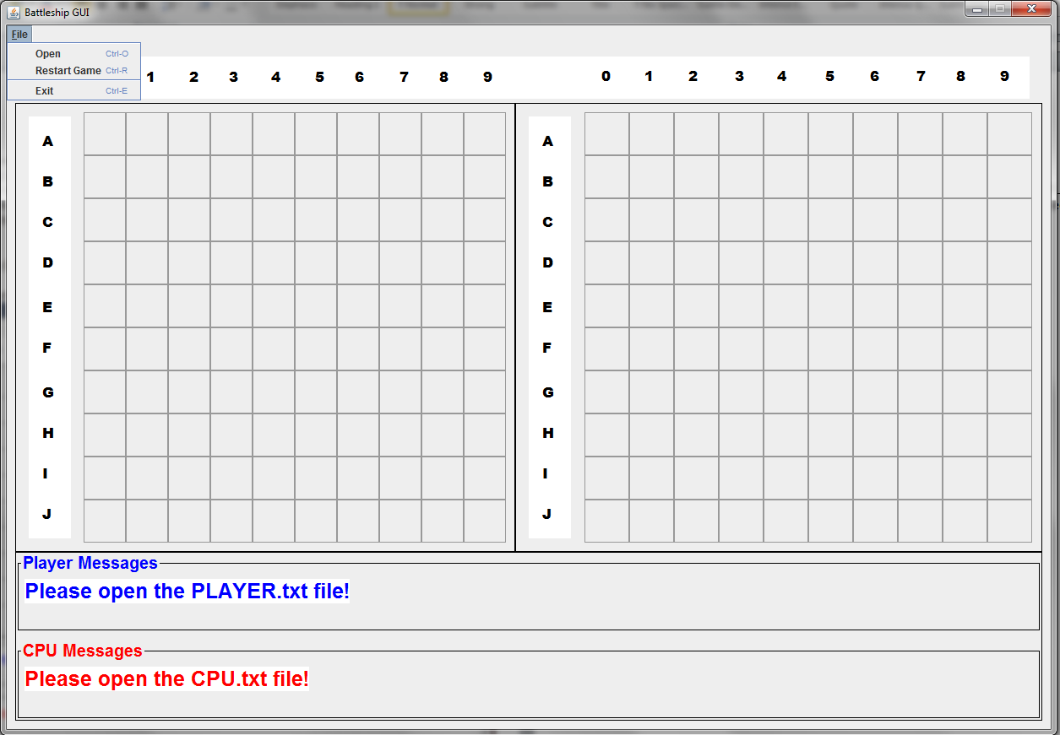

Don’t worry about user input until you get the GUI properly laid out; this will save you a lot of time later. When the user sees this screen, there is nothing to interact with except the menu. In other words, click on the empty grid will not do anything. You will find the following resources useful:
- JMenu tutorial
- JFileChooser tutorial
- Using BorderLayout with JPanel

Part 2 – Loading the Board Files

Like last time, the player and cpu boards will be loaded via files named PLAYER.TXT and CPU.TXT, respectively. See the following images as they are self-explanatory:
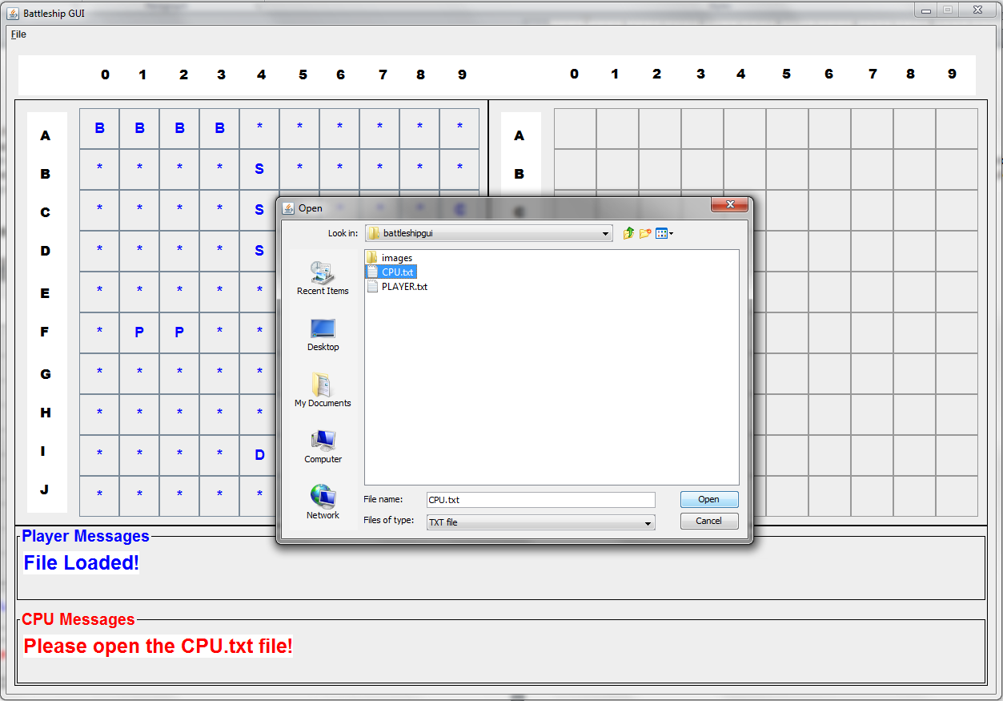

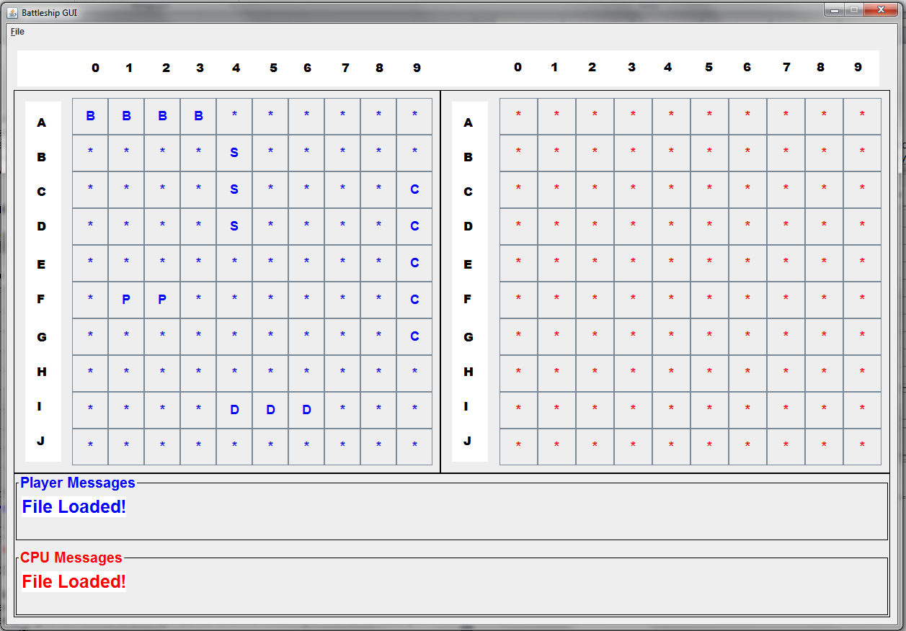

Once the files are loaded, the game can begin and the right-side buttons become active.

Part 3 – Making Moves

The following screenshots cover all the scenarios you will run into:

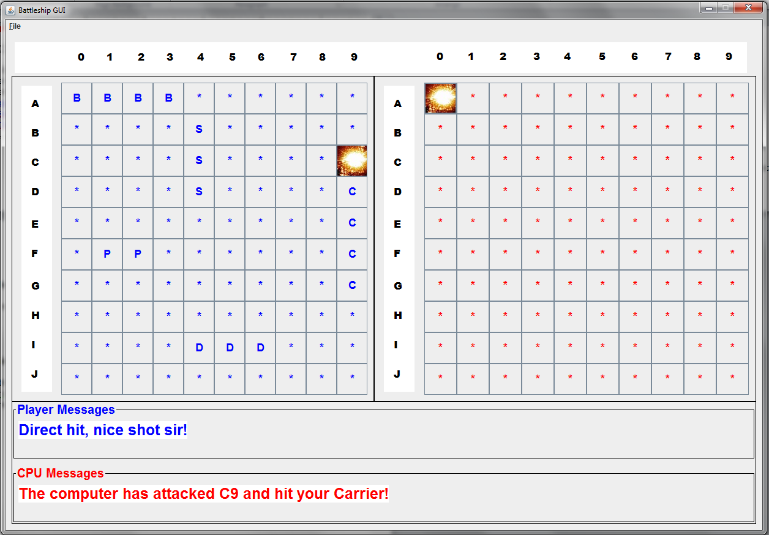

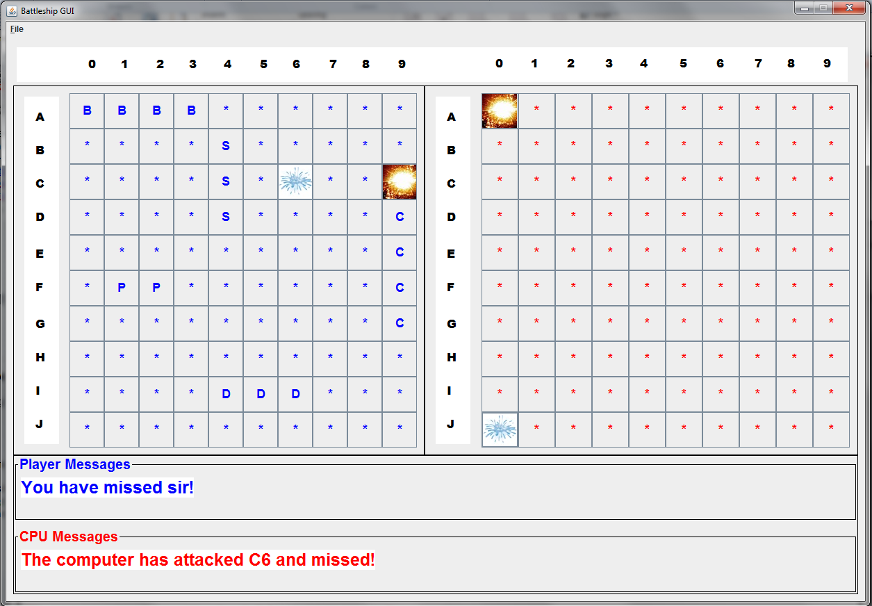

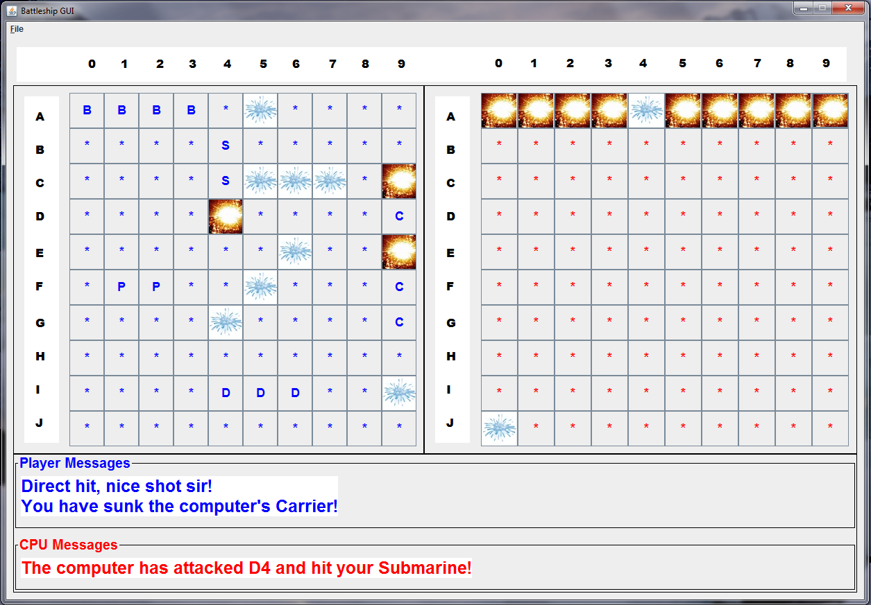

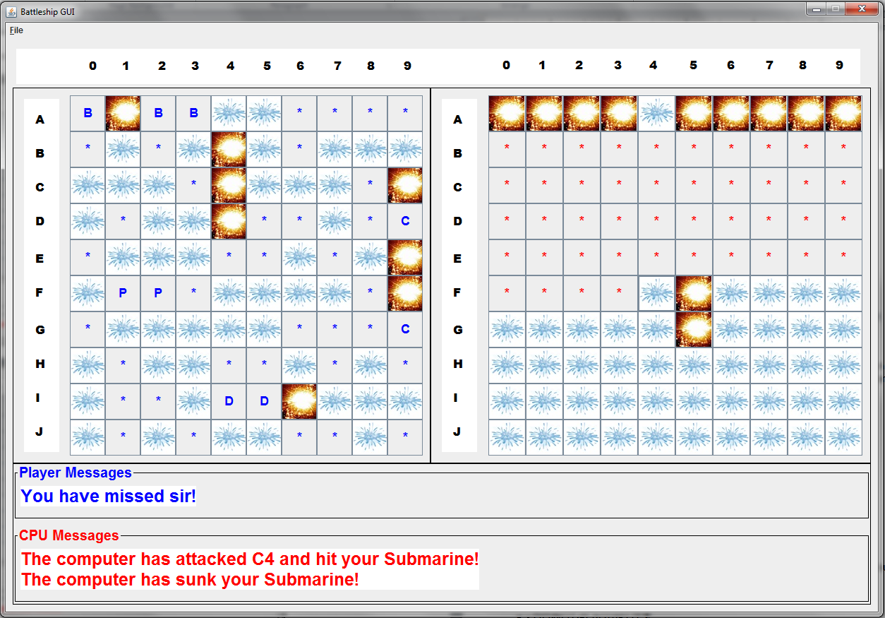

Part 4 – Winner

Upon victory, a dialogue box should announce the winner, and neither player should be allowed to make further attacks. See the following image:

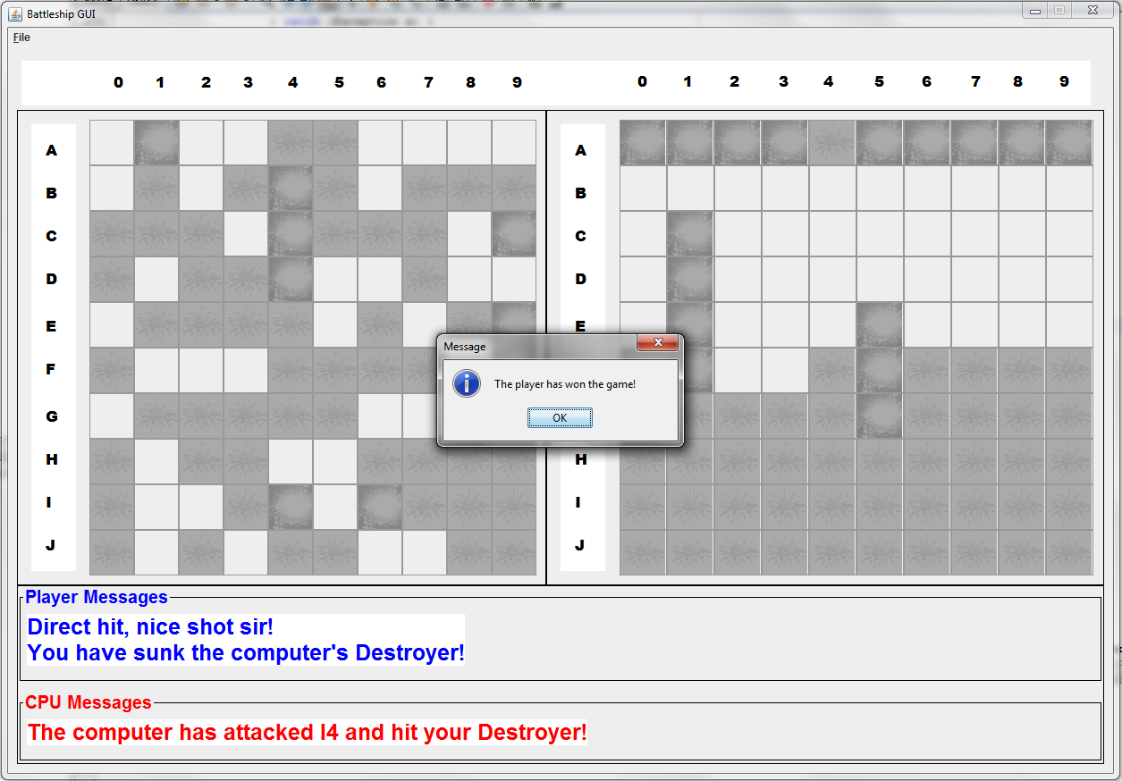

Part 5 – Restart

When the “Restart Game” menu is selected, the program reverts to its starting state.

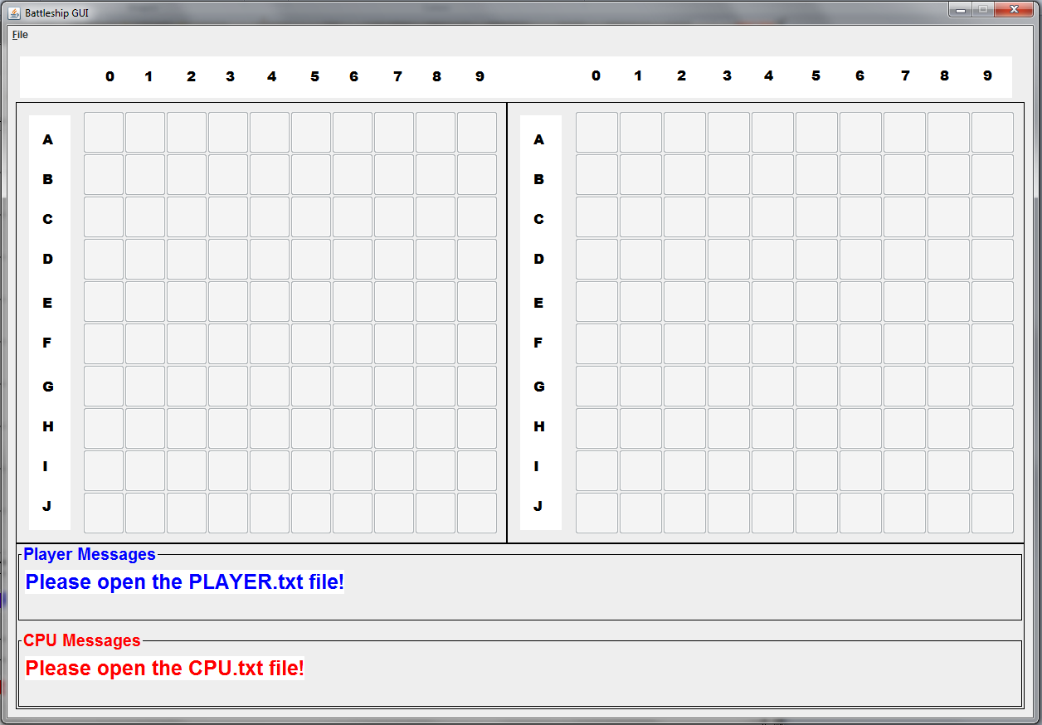

Part 6 – Exit

This menu option will cause the program to terminate.

Additional Notes:
- DO NOT PLAGIARIZE
- Do not procrastinate
- Follow proper coding conventions ➔ spacing, naming, commenting, … etc
- You must work in groups of two minimum, three maximum

Due Date: Friday, April 5, 2013 in class

